Employee ID: 46185397

Name: Rahul Kumar Rajak

**Case Study 11: Using table1(ZXXXLFA1) and Table 2(ZXXXEKKO) which created earlier, create interactive report, where Lifnr is common filed in both the table, So using that common field create a program.**

**Solution:**

**First I created two tables ZRA_EKKO AND ZRA_LIF1.**

**CODE:**

REPORT zrahul_cs11.  
  
TABLES : zra_ekko,zra_lif1.  
  
SELECTION-SCREEN BEGIN OF BLOCK b1 WITH FRAME TITLE TEXT-001.  
  
PARAMETERS : p_row TYPE sy-tabix.  
  
SELECTION-SCREEN END OF BLOCK b1.  
  
START-OF-SELECTION.  
  
  SELECT lifnr, bukrs, bstyp  
    FROM zra_ekko  
    INTO TABLE @DATA(it_ekko)  
    UP TO @p_row ROWS.  
  
END-OF-SELECTION.  
  
  LOOP AT it_ekko INTO DATA(wa_ekko).  
    AT FIRST.  
      FORMAT COLOR COL_HEADING.  
      WRITE : /5 'VENDOR',  
              50 'COMP CODE',  
              30 'DOC CAT'.  
      FORMAT COLOR OFF.  
    ENDAT.  
  
    FORMAT COLOR COL_NORMAL.  
  
    WRITE : /5 wa_ekko-lifnr,  
             50 wa_ekko-bukrs RIGHT-JUSTIFIED,  
             30 wa_ekko-bstyp.  
  
    HIDE : wa_ekko-lifnr.  
    FORMAT COLOR OFF.  
  ENDLOOP.  
  
AT LINE-SELECTION.  
  SELECT lifnr, land1,name1,name2,ort01,pfach  
   FROM zra_lif1  
   INTO TABLE @DATA(it_laf1)  
  WHERE lifnr EQ @wa_ekko-lifnr.  
  
  LOOP AT it_laf1 INTO DATA(wa_laf1).  
    AT FIRST.  
      FORMAT COLOR COL_HEADING.  
      WRITE : /5 'VENDOR',  
              20 'COUNTRY',  
              56 'NAME1',  
              75 'NAME2',  
              96 'CITY',  
              115 'PO_BOX'.  
      FORMAT COLOR OFF.  
    ENDAT.  
  
    FORMAT COLOR COL_NORMAL.  
    WRITE : /5 wa_laf1-lifnr,  
             20 wa_laf1-land1,  
             56 wa_laf1-name1,  
             75 wa_laf1-name2,  
             96 wa_laf1-ort01,  
             115 wa_laf1-pfach RIGHT-JUSTIFIED.  
    FORMAT COLOR OFF.  
  ENDLOOP.  
  
TOP-OF-PAGE.  
  WRITE : 'HEADER DATA'.  
  
TOP-OF-PAGE DURING LINE-SELECTION.  
  WRITE : 'ITEM DATA'.

Provide input as 5:

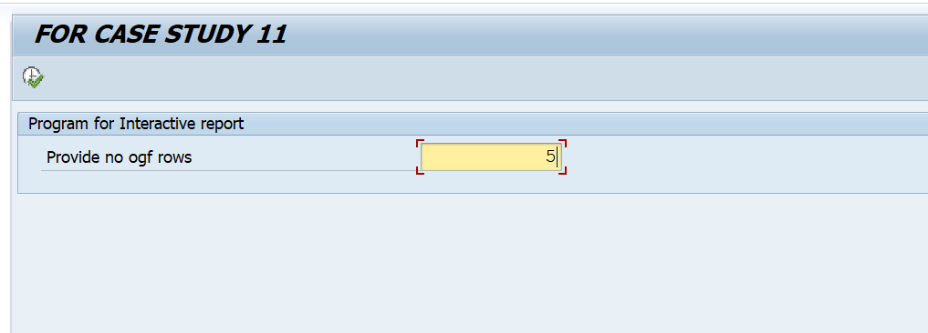

Output:

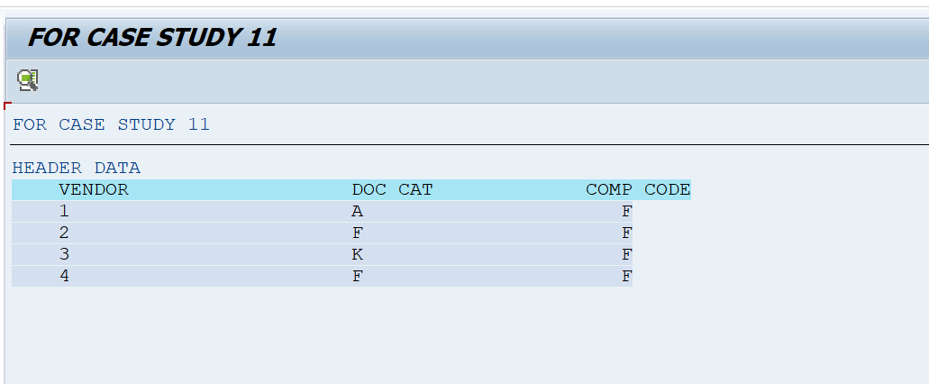Output after clicking the vendor 2:

